- Introduction (who is the client, what is the project about)

We will create a Solar energy calculator for the client named Bengt Stridh. It will be created using web technologies. It will be a tool for determining what investments in solar energy that is suitable depending on some parameters.

charlie (suggestion): We are going to do a project for the client named Bengt Stridh from the Future Energy Center research specialization at Mälardalen University. The following project background has been given by the client, which specifies what the project is all about: “The Future Energy Center research specialization at Mälardalen University has in a previous project developed detailed models to analyze investment decisions for photovoltaic (PV) plants in Sweden. The task in this project is to develop a web-based tool to support different stakeholders, such as companies and private persons, to determine what investments in solar energy are suitable for them based on a number of default parameters that can be adjusted by the user. The photovoltaic market has been growing strongly during the last years. However, in general the knowledge of PV among potential investors is low. Therefore, there is a strong need for a user friendly tool to calculate production cost and profitability for PV investments in Sweden.”

- Project organization
  - Project group (members, contact info, roles or responsibilities)

Name | Email | Role/Responsibilities
Lukas Hamacek |  | Project manager
Aliya Hussain | syeda.aliya.hussain@gmail.com | Documentation and presentation
Charlie Höglund | c.hoglund@live.se | Trello manager
Jonathan Larsson |  | Configuration manager (SVN/Github)
Sebastian Lindgren |  | Client contact
Avalika Podduturu Reddy

OBS. The roles or responsibilities might change during the project (e.g. if a person is more suitable for a role/responsibility).

  - Organization and communication (how and when will you meet, other forms of contact, other routines (e.g. how should worked hours and results be reported), configuration management)

Rules and Regulations
1. If you cannot attend a group meeting you must tell the group about this.
The earlier the better. If you miss a group meeting the attending group
members will proceed as usual but you will have limited influence on the
matters discussed in that meeting. If you repeatedly miss meetings the
group will have to tell the teachers and measures will have to be taken.
2. If you are late to a meeting you should tell the group about this on the
message service slack. The meeting should not be delayed more than 15
minutes if the group does not agree to do so internally.
3. All decisions should be done democratically by popular vote. Since the size
of the group creates a risk for a 50-50-vote situation the project manager
will have a deciding vote in these situations. Before the decision each side
have a chance to motivate why their decision is the best for the project.
4. The work to be done is to be put in a backlog available to all users.
Deadlines (where applicable) and responsible members should be assigned
for each task. The work should then flow by itself but if necessary it is up
to the group members to remind each other about the work. This could
be done on the weekly group meetings or on slack.
5. A group meeting should happen at least once each week. In this the re-
spective group members should briefly tell the rest about the work he/she
has done and it’s current status. This could also easily be done by refer-
encing to their github activity. If any member is stuck on their assigned
problem the group will help him/her to solve it. This does not mean that
a member can keep letting others do their work. It means that the group
will help by discussing or in worst case by two members switching jobs.

We should also write how to to report hours and results, configure management etc.

charlie (things that could be mentioned): we will have project meetings with the external steering group in the school’s facilities every monday. we will have at least one internal project meeting per week (physical/non-physical). a good thing could also be to have an internal project meeting before the meeting with the external steering group, which allows the group to go through the material to be presented. forms of contact are physical (in the school) or non-physical (over slack, email, phone…).

charlie (thoughts): we could report worked hours by using a simple table (see example of a table below) inside a document on github (might be good templates online)? results are just reported by uploading/committing them on github which allows everyone else to see them? configuration management - how the uploaded files are managed (who decides commits...)?

Name | Week 1 | Week 2 | ...
Charlie | 4 hours | 2 hours | ...

  - Planned effort per member for each week in the project (should sum up to roughly 150 hours per student, which includes all project work e.g. scheduled presentations etc.), and known absences

This project course is 7.5HP which corresponds to 5 hours every workday for
8 weeks or 200 hours in total for each member. The members can chose for
themselves how they divide their 200 hours but the majority should be in the
start of the project. In these hours all your individual work and group meeting
times are counted. The mandatory meetings with the teacher are also counted.

charlie (thoughts): should be approximately 20 hours/week for each student (20*8=160 hours). could be a good idea to write down/talk about possible absences soon.

  - Deliverables, deadlines and milestones, both external (e.g. defined by the steering group) and internal (decided by the group). Activities you have already defined (meetings and presentations, presentation preparation, documentation, etc.), when they are planned and how much effort they will require. A Gantt chart can be a good way to present an overview.

External:
Document |  | First version |  | Final version
Project plan |  |  |  | Nov 17
Design description |  | Dec 1 |  | Jan 12
Product |  | Dec 1 |  | Jan 12
Project report |  |  |  | Jan 12

Internal:
Activity To be done (date)
Learn and use github 16 Nov
Learn and use trello 16 Nov
Learn any lacking web skills 30 Nov
User (design friendliness) test 16 Dec
Internal final project report ready (revisions ok) 10 Jan

  - Quality assurance (any planned activities or routines for ensuring quality, both regarding the final product and other deliverables)

We will use unit testing to assure the quality of the different parts of the system. Then we will do an integration test to assure that all ofthe parts works as expected when working as a system. Then we will test the system with people to see that the system works as expected in a real scenario. The unit testing will be done right after each unit/part is implemented .

charlie (thoughts): it says “other deliverables” too, not just implemented code (final product). this probably refers to documentation like the project plan, design description, and project report. therefore it might be quality assurance when having an activity where some group members read through the text/look at models and diagrams to double check for grammatical mistakes, logical mistakes etc.

- Description of the system to be developed
  - High level description of the domain and the problem

A preliminary specification has been provided by the project provider. The tool
should be able to dynamically change as the market changes. It should be able
to help the users to understand what they are doing and make a good decision.
The user should be able to be given some default values. This should be done
with great care, maybe by informing the user that the values are default. The
program should also
• Save used input values from one session to the other
• Switch between Swedish and English language
• Compare the calculated values for two sets of input parameters.
The output should contain production cost, profitability, cash flow. Diagrams
with present values, cost shares and income shares. There should also be a
possibility to make a report file that could be printed with input and output
values.
Since the calculator should be able to easily be kept up to date it should be
easy to update guiding texts and default values as well as suggested minimum
and maximum values.
If possible the updates of the system should be made by uploading an up-
dated Excel-file.

  - Description of existing systems, if the project is about extending or improving something that exists, or the context i.e., any existing or planned entities that the developed system should interact with but which will not be developed in the project (for example physical equipment, or an existing database).

TODO (remove this todo when you start the work) Describe the excell file/system we have now.

  - High-level description of the desired functionality, for example captured by a use-case diagram (note, however, that you probably don't have enough knowledge at this point to include detailed descriptions of each use-case).

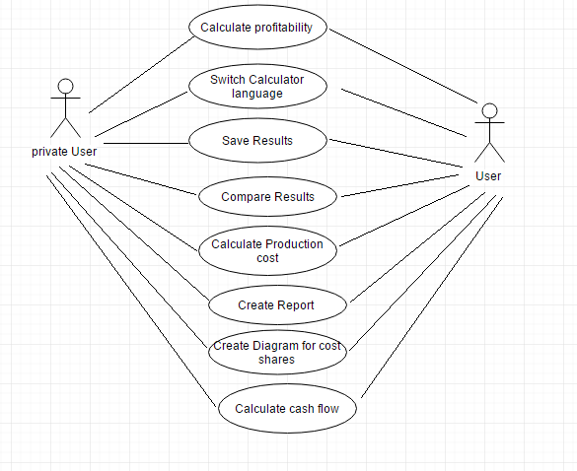

  - If needed, you can also list additional functional or non-functional requirements that are not covered by the backlog.

- Initial project backlog
  - The initial list of system features to be implemented. Define priority/importance for each entry in the backlog, and a rough effort estimation in person-hours. Try to define individual implementable user features, rather than development/implementation tasks. Formulating them as user stories can help: "As (who), I want to (what) so that (why)".

I made a PDF for this. I will send it on slack so all can see it. (It was difficult to add here :P)

